Cost_analysis

Lihai

2/9/2021

## Data preparation

Trying using QRLMM packageds to run quantile regression mixed model:

treat = c()  
treat[SHUNTRND=="1:MBTS"]=1  
treat[!SHUNTRND=="1:MBTS"]=2  
  
y = cum_cost #response  
x = cbind(1,treat,stage) #design matrix for fixed effects  
z = cbind(1,stage) #design matrix for random effects  
#A median regression  
# median_reg = QRLMM(y,x,z,blind_id,MaxIter = 500)

## Modeling

cost_qt <- QRLMM(y,x,z,blind_id,p=c(0.5,0.9),precision=0.001,MaxIter=100,M=10,cp=0.25,  
 beta=NA,sigma=NA,Psi=NA,show.convergence=TRUE,CI=95)

##   
## ---------------------------------------------------  
## Quantile Regression for Linear Mixed Model  
## ---------------------------------------------------  
##   
## Quantile = 0.5 0.9  
## Subjects = 276 ; Observations = 1312   
##   
## -----------  
## Estimates  
## -----------  
##   
## - Fixed effects   
##   
## Estimate Std. Error Inf CI95% Sup CI95% z value Pr(>|z|)  
## beta 1 200185.93 26669.855 147913.01 252458.85 7.50607 0.00000  
## beta 2 35480.03 10170.426 15545.99 55414.06 3.48855 0.00049  
## beta 3 100420.06 5982.568 88694.23 112145.89 16.78545 0.00000  
##   
## sigma = 176840.8   
##   
## Random effects Variance-Covariance Matrix matrix   
## z1 z2  
## z1 0.56653 0.06150  
## z2 0.06150 0.37502  
##   
## ------------------------  
## Model selection criteria  
## ------------------------  
##   
## Loglik AIC BIC HQ  
## Value -19014.61 38043.23 38079.48 38056.82  
##   
## -------  
## Details  
## -------  
##   
## Convergence reached? = FALSE  
## Iterations = 100 / 100  
## Criteria = 0.00371  
## MC sample = 10  
## Cut point = 0.25  
## Processing time = 11.86964 mins  
## ---------------------------------------------------  
## Quantile Regression for Linear Mixed Model  
## ---------------------------------------------------  
##   
## Quantile = 0.5 0.9  
## Subjects = 276 ; Observations = 1312   
##   
## -----------  
## Estimates  
## -----------  
##   
## - Fixed effects   
##   
## Estimate Std. Error Inf CI95% Sup CI95% z value Pr(>|z|)  
## beta 1 319625.0 32387.496 256145.5 383104.5 9.86878 0  
## beta 2 357817.9 17009.500 324479.2 391156.5 21.03635 0  
## beta 3 174207.7 7119.823 160252.8 188162.6 24.46798 0  
##   
## sigma = 144164.2   
##   
## Random effects Variance-Covariance Matrix matrix   
## z1 z2  
## z1 0.29777 0.04702  
## z2 0.04702 0.40436  
##   
## ------------------------  
## Model selection criteria  
## ------------------------  
##   
## Loglik AIC BIC HQ  
## Value -20086.74 40187.49 40223.74 40201.08  
##   
## -------  
## Details  
## -------  
##   
## Convergence reached? = FALSE  
## Iterations = 100 / 100  
## Criteria = 0.00476  
## MC sample = 10  
## Cut point = 0.25  
## Processing time = 11.93908 mins

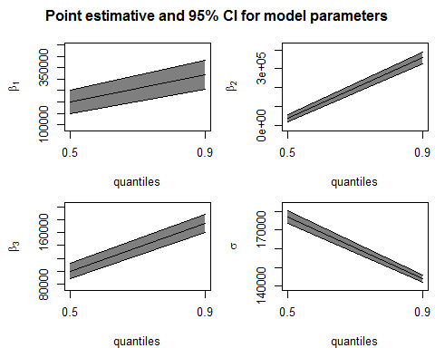

##   
## Press [ENTER] to see next plot:

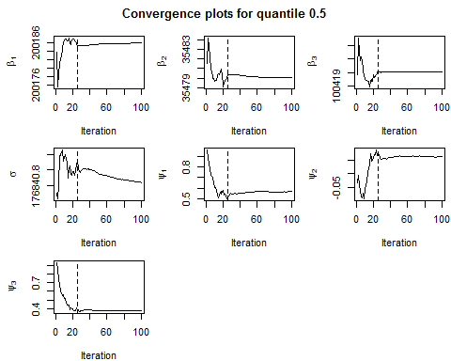

##   
## Press [ENTER] to see next plot:

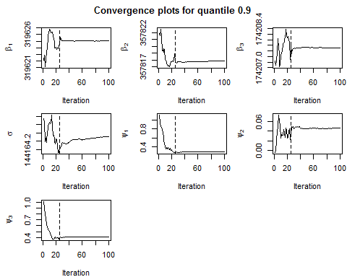

## Including Plots

You can also embed plots, for example:

## Length Class Mode  
## [1,] 2 -none- list  
## [2,] 2 -none- list

Note that the echo = FALSE parameter was added to the code chunk to prevent printing of the R code that generated the plot.